**Practical 01  
Identify the components of a personal computer (PC)**

In this practical, you will examine the motherboards of some personal computers and learn to categorize the components indicated in the pictures as:

1. Central Processing Unit (CPU) [ALU + Control Logic]
2. Memory
3. CPU Cache
4. Input/output, Network Interface Card
5. **Identifying the CPU of your own PC**
6. To find the exact processor model on your Windows 10 or Windows 8.1 computer, you can look for ‘***System Information***’ in search. On the detailed system informationpanel, you can identify the model of the processor (look for the model number).

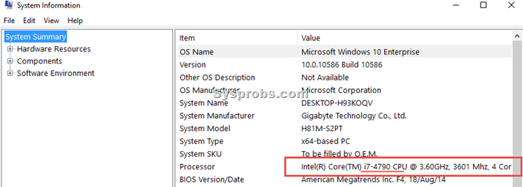

1. Write down your observation:

|  |  |
| --- | --- |
| **System Type (32bit or 64bit)** | **64bit (I’ll be surprised if people actually use 32 bit today)** |
| **Processor Model** | **(12th Gen Intel(R) Core(TM) i7-1255U)** |
| **Number of CORES** | **10 Cores (2 performance cores, 8 efficiency cores)** |

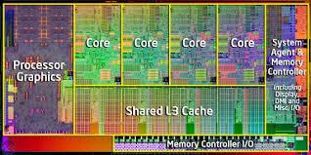

1. **Identifying the Memory of your own PC**
   1. Observe and write down the physical memory: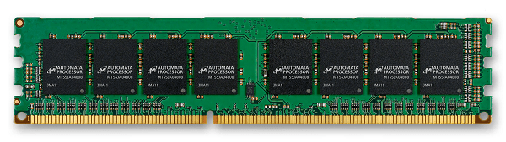

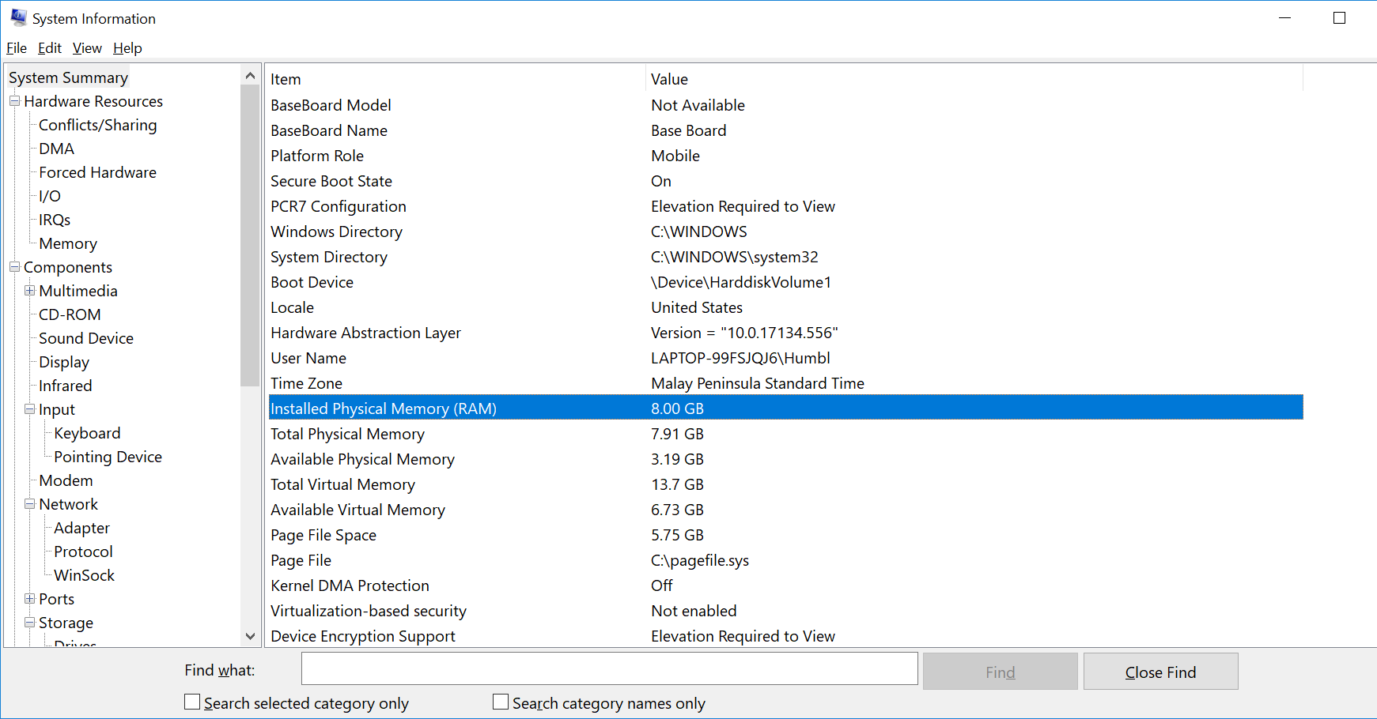

|  |  |
| --- | --- |
| **Size of the physical memory** | **16.0GB (15.7GB Total Physical)** |
|  |  |



|  |
| --- |
| Memory capacity: The more gigabytes (GB) your memory module has, the more programs you can have open at once.   * 2-4 GB. This was the standard RAM capacity and shipped with systems running Windows Vista or XP. This amount of memory could handle single applications. If your system has less than 4GB of RAM, adding more RAM would greatly improve its performance. * 4-6 GB. This standard RAM capacity will handle an average user's tasks, such as web browsing, working in Word documents, and emailing, with ease. * 6-8 GB. This larger RAM capacity works great for casual gamers and basic multimedia users. It can handle multiple programs open at one time and new technology so that users don't have to upgrade when their needs change. * 8+ GB. This robust RAM capacity is perfect for hardcore gamers and high-end multimedia users and creators. These users want to try the newest technology on the market without upgrading their RAM. |

Memory Speed: The amount of time that it takes RAM to receive a request from the processor and then read or write data. Generally, the faster the RAM, the faster the processing speed.

Search google to find the Speed of typical physical memory for your PC.

RAM speed is measured in Megahertz (MHz), millions of cycles per second, so that it can be compared to your processor's clock speed

1. **CPU Cache**
   1. Based on the model of the processor in previous step, search google for the CPU model, take note of the CPU CACHE size

|  |  |
| --- | --- |
| **CPU Cache size** | 12 MB Intel® Smart Cache |
|  |  |
|  |  |
|  |  |

* 1. Download and install cpu-z from [**https://www.cpuid.com/downloads/cpu-z/cpu-z_1.87-en.exe**](https://www.cpuid.com/downloads/cpu-z/cpu-z_1.87-en.exe)
  2. Check the CPU Cache size:

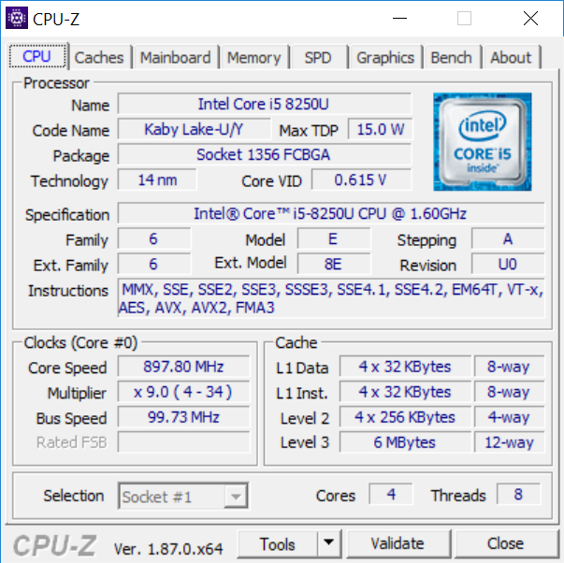

* 1. Take note and write down the Cache size:

|  |  |
| --- | --- |
| **L1 Data** | **48KB** |
| **L1 Inst** | **32KB** |
| **Level 2** | **1280KB** |
| **Level 3** | **12MB** |
|  |  |

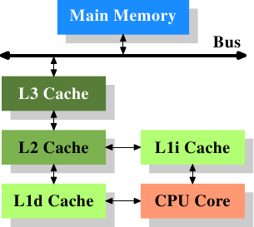

**Explain how CPU cache can enhance the computer speed by referring to the picture:**

|  |
| --- |
| **Explain how CPU cache can enhance the computer speed** |
| **Characteristics of CPU cache:**   1. **An adjunct to the main memory, fabricated on the processor chip** 2. **Much smaller and faster than the main memory** 3. **Holds sections of the program and data currently/frequently being executed** 4. **Type of cache (Data vs Instruction and levels of cache)**   **How the characteristics influence the speed:**   1. **An adjunct to the main memory, fabricated on the processor chip: By being on the same chip as the processor, CPU cache drastically reduces the time it takes for the processor to access data. This proximity eliminates the need to fetch data from external memory modules, which would otherwise involve longer latency due to physical distance. The physical proximity of CPU cache to the CPU core reduces the distance that signals need to travel, resulting in lower latency. This closeness allows for faster communication between the processor and cache, further enhancing processing speed.** 2. **Much smaller and faster than the main memory: The smaller size of CPU cache allows for faster access times compared to main memory. Since cache is made up of faster memory technologies like SRAM (Static Random Access Memory), retrieving data from cache is quicker than fetching it from the slower DRAM (Dynamic Random Access Memory) used in main memory.** 3. **Holds sections of the program and data currently/frequently being executed: By storing frequently accessed data and instructions, CPU cache reduces the need for the processor to access slower main memory repeatedly. This means that the processor can quickly retrieve the data it needs without having to wait for it to be fetched from main memory, thereby speeding up overall processing.** 4. **Type of cache (levels): CPU cache comes in different levels (L1, L2, L3) with varying sizes and speeds. The hierarchical structure of CPU cache ensures that frequently accessed data is stored in the fastest, smallest cache (L1), while less frequently accessed data is stored in larger but slower caches (L2, L3). This tiered approach optimizes the speed of processing by ensuring that the most critical data is readily available to the CPU at all times.**   **Type of cache (instruction and data, since the instructions said based on the image):**  **Instruction Cache:**   1. **Stores frequently accessed instructions: The instruction cache holds frequently used machine instructions, such as arithmetic operations and branching instructions. By storing these instructions close to the CPU core, the processor can quickly fetch and execute them without having to wait for them to be retrieved from slower main memory.** 2. **Reduces instruction fetch latency: Since instruction cache is physically closer to the CPU core than main memory, fetching instructions from the cache incurs lower latency. This proximity allows the processor to fetch the next instruction in the program sequence more quickly, thereby improving instruction throughput and overall processing speed.** 3. **Optimizes instruction execution: By prefetching and storing instructions ahead of time, the instruction cache helps mitigate potential stalls in the instruction pipeline. This ensures that the CPU remains busy executing instructions, leading to higher throughput and faster program execution.**   **Data Cache:**   1. **Stores frequently accessed data: Similar to instruction cache, data cache holds frequently accessed data items such as variables, arrays, and data structures. By caching this data close to the CPU core, the processor can quickly access and manipulate it without incurring the latency associated with fetching data from main memory.** 2. **Reduces data access latency: Accessing data from the data cache is much faster than fetching it from main memory due to the cache's proximity to the CPU core. This lower latency translates to faster data read and write operations, which are essential for improving overall processing speed, especially in data-intensive applications.** 3. **Minimizes memory bandwidth usage: By caching frequently accessed data items, the data cache reduces the need for the processor to access main memory frequently. This helps conserve memory bandwidth, allowing more efficient utilization of the available memory resources and improving overall system performance.**   **I hope this was enough, I asked the teacher and he said: “I let you decide if this is enough or not.”** |

* 1. RAM upgrades are limited by the capability of the system and the availability of expansion slots for adding RAM. Check if you have expanded RAM on your computer.  
       
     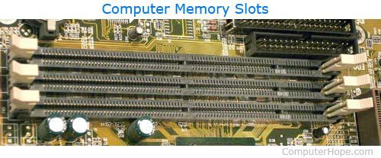

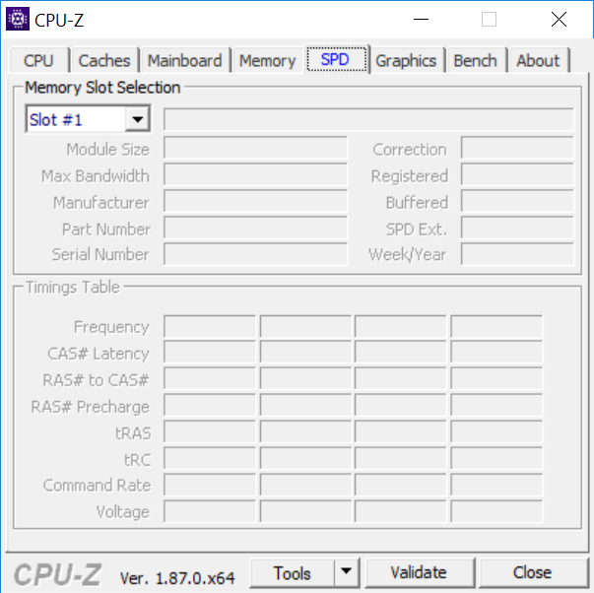

|  |
| --- |
| **How many slots are used for memory expansion?** |
| **2 (Note for marker, I tried to get a screenshot with the snipping tool but it seems that every time I take a screenshot the dropdown selection for the slot disappears, this was after a few attempts and the best I could do, I’m sorry)** |

1. **Network Interface Card**

## Ethernet Card

Ethernet card, also known as network interface card (NIC), is a hardware component used by computers to connect to Ethernet LAN and communicate with other devices on the LAN. The earliest Ethernet cards were external to the system and needed to be installed manually. In modern computer systems, it is an internal hardware component. The NIC has RJ45 socketwhere network cable is physically plugged in.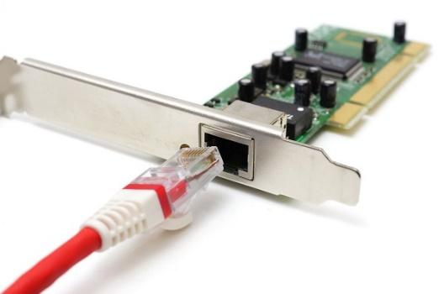

1. Go to command window by typing run cmd

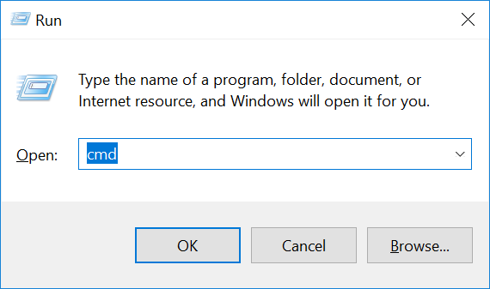

1. Type the following command in the command window

|  |
| --- |
| systeminfo |

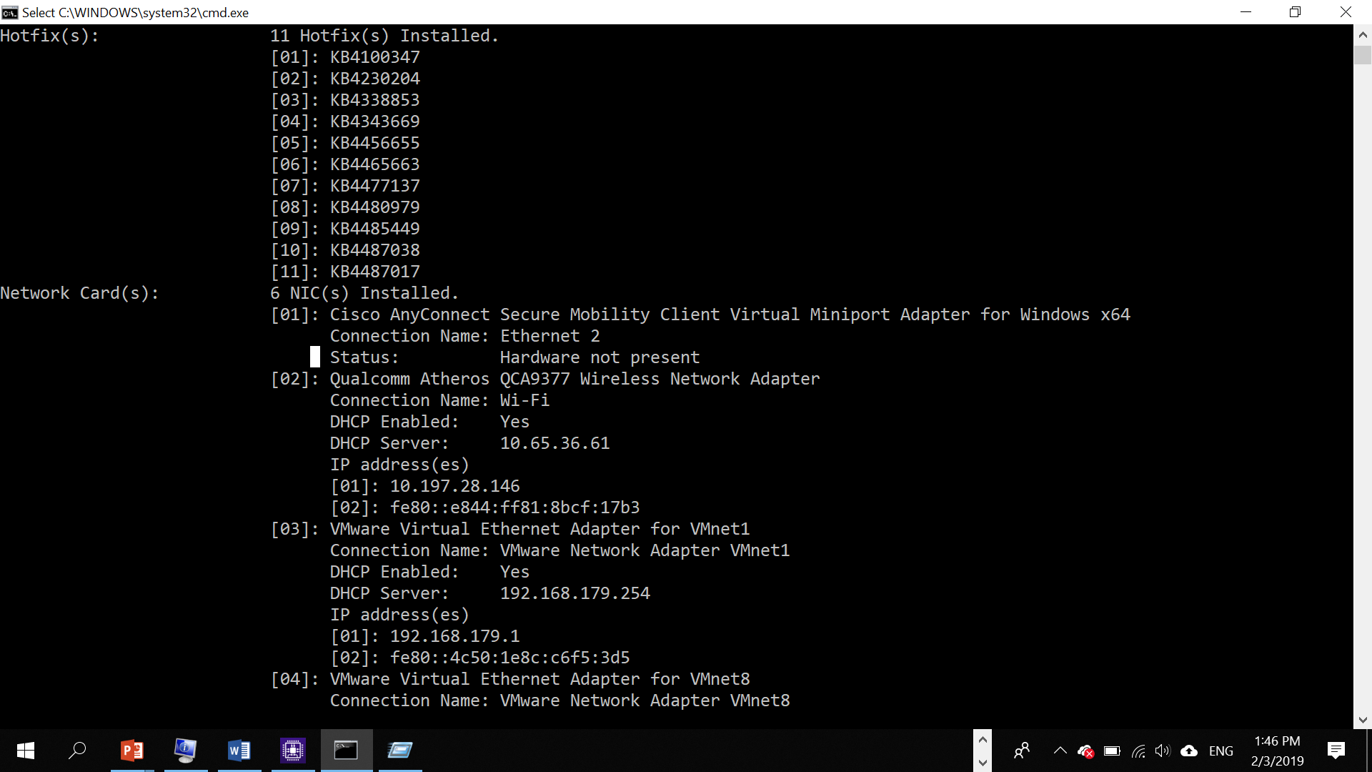

Type the command:

|  |
| --- |
| ipconfig /all |

1. Observe the result and record down:

|  |  |
| --- | --- |
| **Ethernet NIC** |  |
| **model** | **Realtek PCIe GbE Family Controller** |
| **IP address** | **192.168.0.13** |
| **MAC address** | **08-8F-C3-64-CD-C8** |
| **Wireless NIC model** |  |
| **Model** | **MediaTek 802.11AC MT7663 Wireless LAN Card** |
| **IP address** | **172.22.55.245** |
| **MAC Address** | **9E-2F-9D-5F-AE-27** |
|  |  |

According to my teacher I can use a random address for the ethernet because all the ports in my router are connected for other things (plex server and a homelab)

1. Based on the model of wireless NIC, find the image of the card, for example: 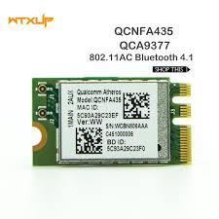   
   A screenshot of a computer

   Description automatically generated

|  |
| --- |
| **Google Search for the following:**  How many bytes for MAC address?  6 bytes long  What is MAC address for ?  Serves as a unique identifier during device manufacturing, this can help identify the machine on the network, this is helpful for identifying the machine should the ip address change.  If you change a new Wifi Card, will your MAC address also change?  Yes, this is because the MAC address is tied to the network interface device (firmware level). |